Norwegian Reservation Number: _________
Norwegian Bliss Voyage Date: ___________
Re: Child’s Name, Age, Gender, with: PKU – Metabolic Condition needing special diet.
Room: __________
Diet Restriction: PKU (Phenylketonuria) – Very low - No protein, as it can cause Brain Damage.

Complete List of Perishable Food that will be brought on board
and given to Chef, of Bliss Norwegian Cruise:

Needs to stay FROZEN (SPOILS EASILY):
- Cambrooke Foods Homestyle Bread - low Protein Bread. (PLEASE Only take one loaf out of freezer at a time)
- Gluten Free LaTortilla Factory tortillas (made with Cassava Flour). (PLEASE Only take one bag of tortillas out of freezer at a time)
- Gluten Free Low Protein Burger Buns/Hot Dog Buns

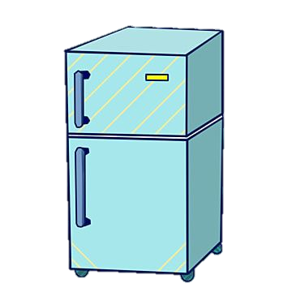
Needs to stay REFRIGERATED:
- Violife or Daiya (Dairy Free, Low Protein) Cheese (Slices and Shredded)
- Almond Milk (once opened)

Dry Storage Items:
- Country Sunrise Imitation Scrambled Eggs & Omelet Mix
- MixQuick (Pancake/Waffle Mix)
- Aproten Pasta
- Cambrooke Foods Shake n’ Cheese
- Country Sunrise Chicken Pattie Mix
- Country Sunrise Hot Dog Mix
- Almond Milk (unopened cartons)
- Kraft Caesar Dressing
- Kraft Ranch Dressing

Items that will stay in our Cabin Room (10258):
- Kellogg’s Rice Krispy Squares (packaged)
- Mott’s Fruitsations
- Quaker Granola Bars
- Low Protein Chips (Wise Onion Rings, Spokes Chips)
- Medical Formula
  - Cambrooke Foods Glytactin RTD 15 Chocolate Medical Formula
  - Bettermilk Powdered Formula, plain
  - Hoping to get in time: Glytactin Complete Medical Protein Bars

