Hayden Knox – Room/Cabin: _____

Hayden Knox’s Special Diet for:

Phenylketonuria

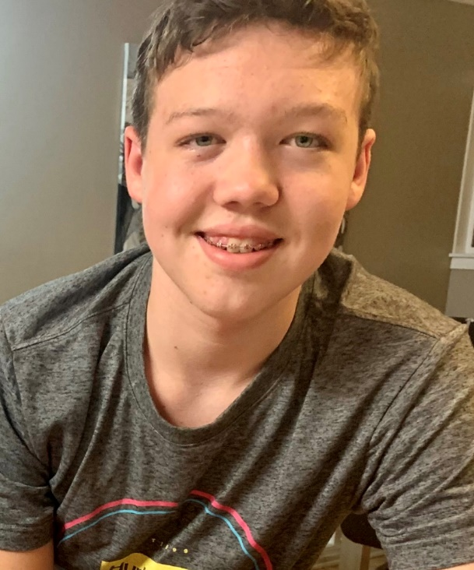 Hayden Knox is a 15 year-old boy with PKU (phenylketonuria). Hayden is allowed to eat 6 grams of protein (or 300mg Phenylalanine) per day.

Phenylalanine (or Phe) is an amino acid found in protein. It is the Phe that is toxic to his brain. Any more than 3 grams protein/day can cause brain damage.

Therefore, he must eat special low protein foods that are purchased at our local Children’s Hospital, specifically for people with PKU. **Even those low protein foods have some protein and so all foods must be carefully weighed and calculated into his diet.**

Here is a quick list of the foods Hayden **cannot** eat:

**Meat, fish, eggs, milk (anything that came from an animal), wheat/gluten, soy, Nuts, legumes, chocolate, Aspartame, and some fruits and vegetables ie. Corn.**

Hayden is very picky about how his food tastes, and can sometimes be challenging to make. We have brought some Low Protein medical foods for Hayden to eat, and the following pages explain how to cook those food items, as it is very different from mainstream foods.

Thank you for your patience and understanding -

Brienna, Hayden’s Mother.

Table of Contents:

Contents

**FAQ** 3

**Breakfast:** 4

**Low Protein Eggs** 4

**Pancakes/Waffles** 5

**Toast/Bread** 5

**FRENCH TOAST** 5

**Lunch/Dinner:** 6

**Grilled Cheese Sandwich** 6

**“Meat”** 7

**“Chicken” Caesar Salad** 7

**Lettuce Wraps** 8

**Cheeseburger** 8

**Pasta** 9

# **FAQ**

**Is Cross-Contamination with “No-Foods” dangerous?**

A little bit of cross-contamination is fine as Hayden’s body needs a small amount of natural protein for growth and development. He won’t have a ‘reaction’ if he gets some natural protein. For example, he can eat fries that have been deep-fried with chicken strips. However, if a steak was grilled on a pan and there are juices etc, the pan should be washed before frying Hayden’s “food” on it.

**Is Butter or Oil safe to use when cooking?**

Yes! Oil has 0 protein. Butter has some protein, so I usually choose oil over butter when preparing a pan. However, it is okay to use Butter or Oil when preparing Hayden’s food.

**Can I use any oil?**

Yes! All oils are phe/protein free. I tend to use mostly olive oil as that is what we use at home. But vegetable oil or canola oil is fine. It is fine to put butter/margarine on his toast.

**Is it okay to use seasonings or spices?**

Yes! Most seasonings/spices are either Phe/Protein free or have very little. Fries are often seasoned with salt, parsley etc. those things are okay. However, Fries that are battered in wheat or covered in gravy are not okay for Hayden. Spices such as cinnamon, ginger, etc are all 0 protein. Mustard comes from mustard SEED so that is higher protein, and Soy Sauce comes from soya so it is also quite high protein. Hayden can have these things, but in very small quantities.

***Safe Seasonings/spices:***

Ketchup, Mayo, salt/pepper, seasoning salt, parsley etc, cinnamon, ginger etc,

***Higher Phe Spices (use in small quantities):***

Soy Sauce, Mustard, NO Parmesan cheese

**How do you get in touch if you have a question?**

You can email me (Brienna) at: ____________________________________

# **Breakfast:**

## **Low Protein Eggs**

Hayden’s imitation eggs can be served as a flat “pancake” style or ‘scrambled’.

**Directions:**

1.) Mix the premeasured Imitation Scrambled Egg (in a baggie labelled: “Egg”) with:

* 1 Tbl Oil and *(you can estimate it – doesn’t have to be exact)*
* ½ Cup Water
* Dash of salt

2.) Whisk together until smooth. *There are natural dyes added for colour, if you see a red or orange colour streaking, just mix it in.*

3.) Add cooking spray (or SMALL amount of oil) to frying pan and cook on medium-low until no longer “raw” inside. You can chop it up with a spatula while cooking to make scrambled eggs, or just plop it on the pan and squish it down with your spatula and keep flipping it like a pancake. *If you use too much oil it will never cook. It just turns gooey – so use a small amount of oil, or preferably cooking spray.*

4.) Try not to brown it if possible. Cook on low if your pan cooks fast.

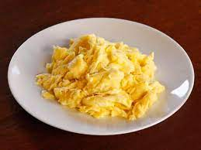

## **Pancakes/Waffles**

*Hayden’s Waffles and Pancakes are very easy to make. Just add water! You want the consistency to be* ***thicker*** *than ‘regular’ pancake mix.*

**Directions:**

1.) Add ¾ Cup MixQuick pancake mix to a bowl

2.) Add ½ Cup Water and whisk until smooth. Add more if its too thick for your liking.

3.) Use batter as you would to make Waffles or Pancakes.

Butter/margarine and Syrup are okay for Hayden to have.

## **Toast/Bread**

****Hayden’s bread won’t toast as quickly as ‘regular’ bread. However, he also won’t eat it if it’s “dark” – or in his mind, ‘burnt’. I know it’s ready when it pops out of the toaster and it’s *just starting* to brown.

* Butter is okay for his toast.
* Please serve with Cinnamon/Sugar Mixture if available.

**FRENCH TOAST:** Water down some of Hayden’s low protein EGG MIX and coat the bread in that, then fry it in a pan like you would with regular French Toast. *I often cook and serve the left over egg mixture (that I had used to coat the bread in), with the French Toast*

# **Lunch/Dinner:**

## **Grilled Cheese Sandwich and SIDE:**

Side: Caesar Salad, OR Veggies and Ranch ie. Cucumbers, Carrots, Broccoli, Cauliflower, Peppers etc

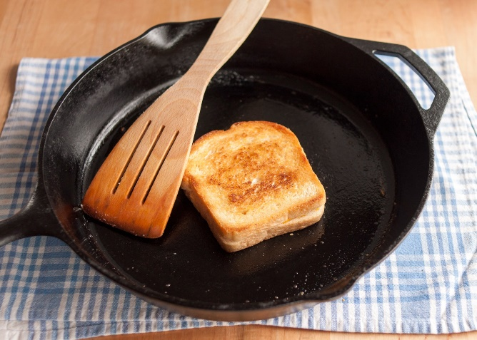

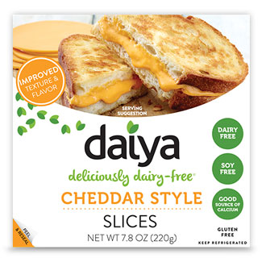

Butter/Margarine on either side of Homestyle Low Protein Bread, Place one slice of low protein Daiya Cheddar Cheese between slices of bread and place on a pan. Cover and cook for 3-5 mins on either side.

**Please serve with either:**

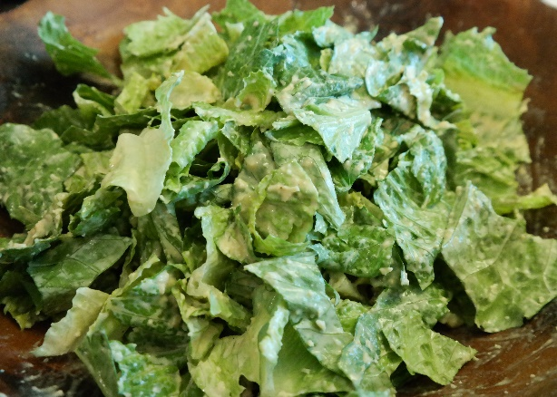**Serve with Caesar salad**

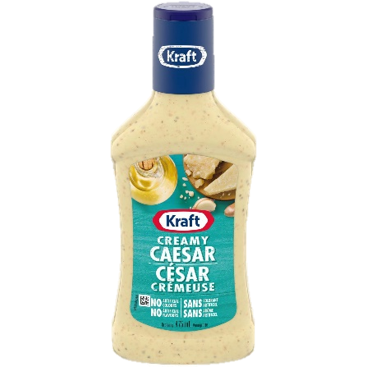Just:

* Romaine lettuce and
* Supplied Caesar dressing *(not homemade as it usually has milk, cream, eggs etc)*

**** NO parmesan cheese or croutons.

**or Veggies and Ranch Dip:**

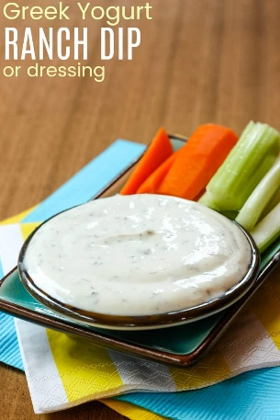 Cucumber, Carrots, Celery, Cauliflower, Broccoli, Peppers etc.

## **“Meat”**

*****Hayden’s ‘meat’ is a staple for him. We actually combine two ‘meats’ together to make his premade meat mixture – Chicken patty mix and Hot dog Mix. He prefers the flavour when we add them together. You will have some* ***premeasured baggies*** *of these two already-mixed ingredients.* ***You will not need to combine mixes*** *– it has already been done. We make Burgers, Lettuce Wraps, Bacon etc out of his “meat”. Sometimes we refer to it as ‘Chicken’ sometimes we call it ‘Meat’.*

**Directions:**

Combine ‘Meat’ mix (in a baggie labelled: ‘Meat’) with:

* + 1 tbl Oil
  + 2 tbl water.

1. We actually mix and squish it around IN the zipped up baggie, but feel free to mix in a bowl if you would prefer. Mix well. If appears too dry, add ½ tbl more water. It will thicken after a minute, as there are starches in the mixture.
2. You can shape the meat ‘dough’ into whatever shape you need for the dish you are preparing (ie. hotdog, burger patty etc), or just mix it, throw it on a pan to cook, chop it up and throw it on a salad ☺

### **Caesar Salad with Parmesan Crisp | Kitchen Bulldog“Chicken” Caesar Salad**

Very Simple! Just:

* Romaine lettuce and
* ****Kraft/any Store brand Caesar dressing *(not homemade as it usually has milk, cream, eggs etc)* *If the dressing says 1gr protein that is too high. If it says 0.1, 0.2, or 0.3gr then he can have it.*

**** NO parmesan cheese or croutons.

* Toss dressing and romaine/lettuce together
* Add One serving of ‘Meat mix’ cooked and chopped up.
* Put on top of Caesar salad and serve.

### **Lettuce Wraps:**

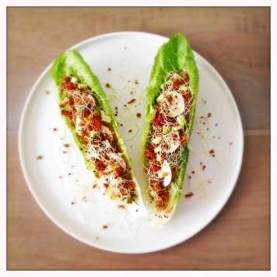**You will need:**

* Low Protein “Meat” (see last page)
* Romaine Lettuce
* Avocado (mashed)
* Salsa (if available)
* Low Protein Cheese (*Violife or Daiya – supplied vegan dairy free cheese*)

Note**: If you do not have avocado or salsa**, you can mix ketchup and mayo together and use that as a sauce.

1. Shape Meat into a patty approx. 1 cm thick (like a PANCAKE) - fry with oil on medium heat until cooked through, approx. 3 mins per side. *Note: this meat can be used as a ‘pate’ so do not worry if you think it is ‘raw’ inside.*

2. Slice Meat into long strips (approx. 5-7 strips).

3. Lay out (approx.) 3-5 Full leaves of Romaine Lettuce on a plate.

4. Mash an **avocado** and spread along the stems of Romaine Lettuce OR (if you don’t have avocado/salsa) spread ketchup/mayo mix down the center of each leaf.

5. Lay a strip of “meat” on each romaine leaf, ripping pieces of meat to make them fit.

6. Sprinkle some low protein Shredded Cheese (Daiya or Violife) onto the lettuce wraps and serve!

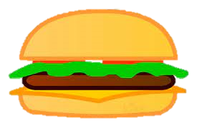

### **Cheeseburger:**

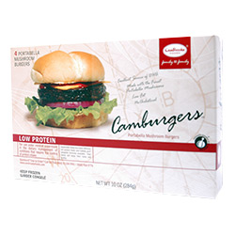Shape into a burger patty. Fry with some oil on medium heat. Approx. 3 mins per side. *IMPORTANT: Please GENTLY toast (just warm in toaster/oven his bun to change the texture of the gluten free bread/bun. Have you eaten gluten free before? It’s a must! Haha*

Add a slice of low protein Cheese (Daiya or Violife) while burger patty is cooking. Serve with a side (Caesar Salad or Veggies and Ranch Dip)

**🡨 NOTE**: Did I send **Camburger Burger Patties**? Great!! Fry up one of those instead! We don’t always have them on hand ☺

## **Pasta**

1.) Bring water and pinch of salt to boil

2.) Add premeasured baggie of dry Aproten Ditalini Noodles – boil until fully cooked (not al dente). Strain and rinse with cool water. Set aside.

3.) Add 1/3 cup water to pot

4.) Add 1½ - 2 tbl Cambrooke Foods Shake ‘N’ Cheese sauce and whisk until combined.

5.) Cook on medium heat until sauce thickens, whisking continuously.

6.) Add cooked pasta and stir.

7.) Serve with Ketchup.

**Hayden’s Menu for (Date):___________**

**In the Box write:**

**‘B’ for Breakfast Choice**

**‘L’ for Lunch Choice and**

**‘D’ for Dinner Choice**



**Foods that Hayden CAN eat off the ‘Regular’ Menu:**

* Apples
* Bananas
* Oranges
* Strawberries
* Grapes/Cherries
* Cucumbers
* Lettuce (Romain)
* Snap Peas
* Carrots
* Bell Peppers

**Meal Options: Total Exch:**



1. Waffle or Pancake – Mixquick 0 exchanges ________

(Mixed with water, cooked, serve with butter/marg and syrup)

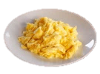

1. Egg – Country Sunrise 2 exchanges ________

(1/4 cup Egg Mix plus 1tbl oil and ¼ cup water)

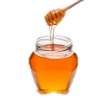

1. Toast – Cambrooke Foods Bread 1.5 exchanges ________

(2 slices Cambrooke Foods Bread, Margarine/butter, honey, jam or cinnamon/sugar)

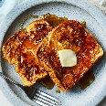

1. French Toast – 3 exchanges ________

(2 slices Cambrooke Foods Bread, Egg mixture and syrup)

****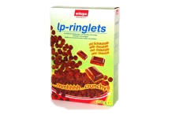

**NO Foods:**

* Corn on the Cob
* Meat/Fish
* Eggs
* Dairy
* Legumes/Nuts
* Wheat
* Soy
* Bread/Cake/Cookies
* Rice
* Chocolate
* Aspartame (No Diet beverages)

1. Low Pro Cereal (LP Ringlets) 0 exchanges ________

(A bowel full with Almond Milk)

1. Pasta 2 exchanges ________

(1 cup dry Aproten Pasta noodles plus

2tbl Shake ‘N Cheese)



1. Grilled Cheese 3 exchanges ________

****(2 slices Cambrooke Foods Bread or Little Northern Bakehouse Gluten Free bread, with butter/marg, Low pro cheese slices)

1. Cheeseburger 9 exchanges ________

Patty: 3.3 exch

Bun: 5.5 exch

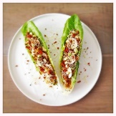(Camburger patty with low protein cheese, served on Little Northern Bakehouse burger bun, VERY slightly toasted – just to change the texture of the gluten free bun. Served with Caesar salad [just romaine and Caesar dressing]

Record Snacks here:

1. Lettuce Wraps 7 exchanges ________

(Romaine, ‘meat mixture’, avocado, low pro cheese and salsa)

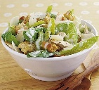

1. “Chicken” Caesar Salad 5.5 exchanges ________

(Meat mix and Caesar dressing/Lettuce)



1. Other: _______________________

_____________________________

_____________________________ Exchanges?: ________

**Total Exchanges from Meals: ________ /20**

**Remaining Exchanges: ________ left**

**(to get to 20 for the day)**